**Mussel dissection** – *Geukensia, Brachidontes* or *Mytilus* – live/frozen

Before you start to dissect note the concentric growth rings and the byssus extending from the shell. **How many growth rings are visible in your specimen**?

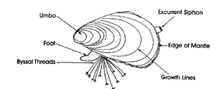

The byssus is produced by the byssus gland at the base of the foot, hardening in a groove that runs midventrally along the foot. Test the strength of the byssal threads by trying to pull them apart. As the byssus is produced, it is attached to the hard bottom on which the animal lives. Producing and attaching byssal threads is the main function of the foot in mussels. As the byssus is used near the anterior, the anterior end of the shell is narrowed and reduced, while the posterior, through which water is exchanged, remains wide. This is reflected in the much smaller anterior than posterior adductor muscle – a heteromyarian ("different-muscle") condition.

You may also be able to see one of the siphons extended.

After examining the exterior, insert the blades of scissors in the widest part of the shell and move back toward the narrow part of the shell, making sure you are not damaging any internal organs. Once a few of the muscles are cut try prying open the shell.

Place in dish provided and then add dilute solution of ethanol. Place the shell down so that the orientation matches the diagram below.

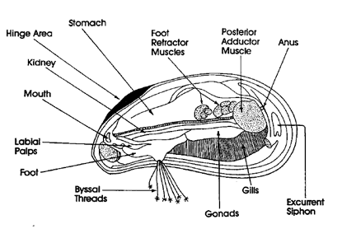

Locate the foot and labial palps, better seen in the photo below. The byssal threads should be extending from a pouch at right angles to the mouth. The gonads will be visible as reddish material on top of a visceral mass. **Take a photograph of the labial palps**, which are used to sort food material. When feeding the food will extend between the palps. The mouth opening can be found just at the end of the foot.

**Take a photo and label the foot.**

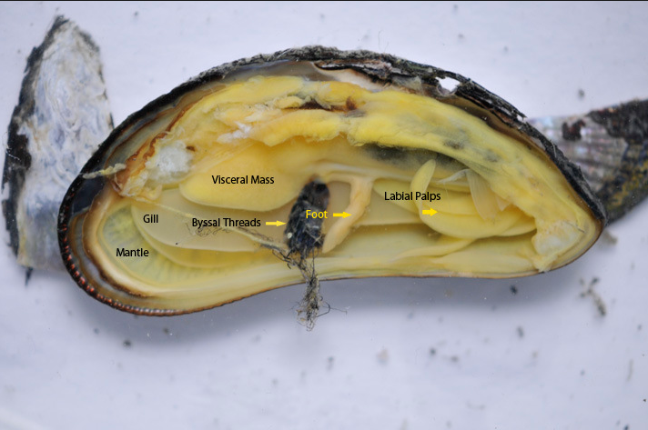

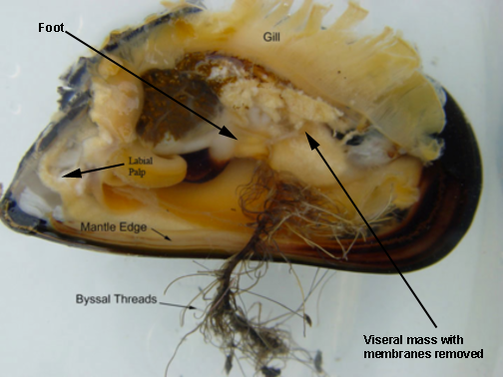

Try to find the siphons and note the filamentous gills. Remove part of the gill and examine it under the microscope. The gills of mussels are very simple in construction. **Photograph the gill (and label the gill)**. In freshwater forms, small larval **glochidia** may be contained inside brood pouches in the gills. **This does not occur in marine gastropods where the larval stage is free swimming**. Prepared slides of glochidia are available however for you to view. Glochidial larvae are ectoparasites on the gills of freshwater fish.

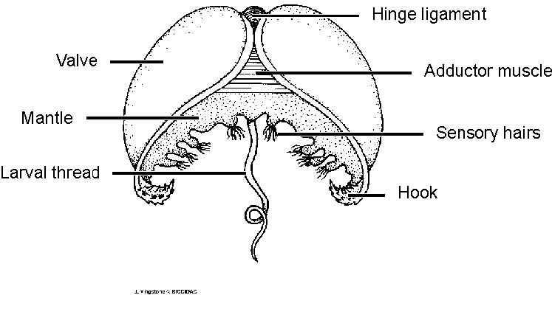

Two diagrams with membranes surrounding visceral mass removed and gills removed to see heart and internal organs can be found below. Try to be careful and remove or at least cut some of the membranes. The very dark structure under the foot is the kidney and the greenish brown structure above is the digestive gland. **You may photograph one of the structures of the digestive tract (labial palp, kidney, etc.) or try for a photograph of the heart**. The intestine coils around, even runs through the pericardial cavity in some species and difficult not to cut. You may try to remove the gill and other structures to see the heart. Again it may be difficult to do this without damaging this structure. If you are careful in removing the gills and locate the stomach, you may be able to trace the intestine back to the heart in the pericardial cavity. If you are successful, please share your specimen and photos with others in the lab.

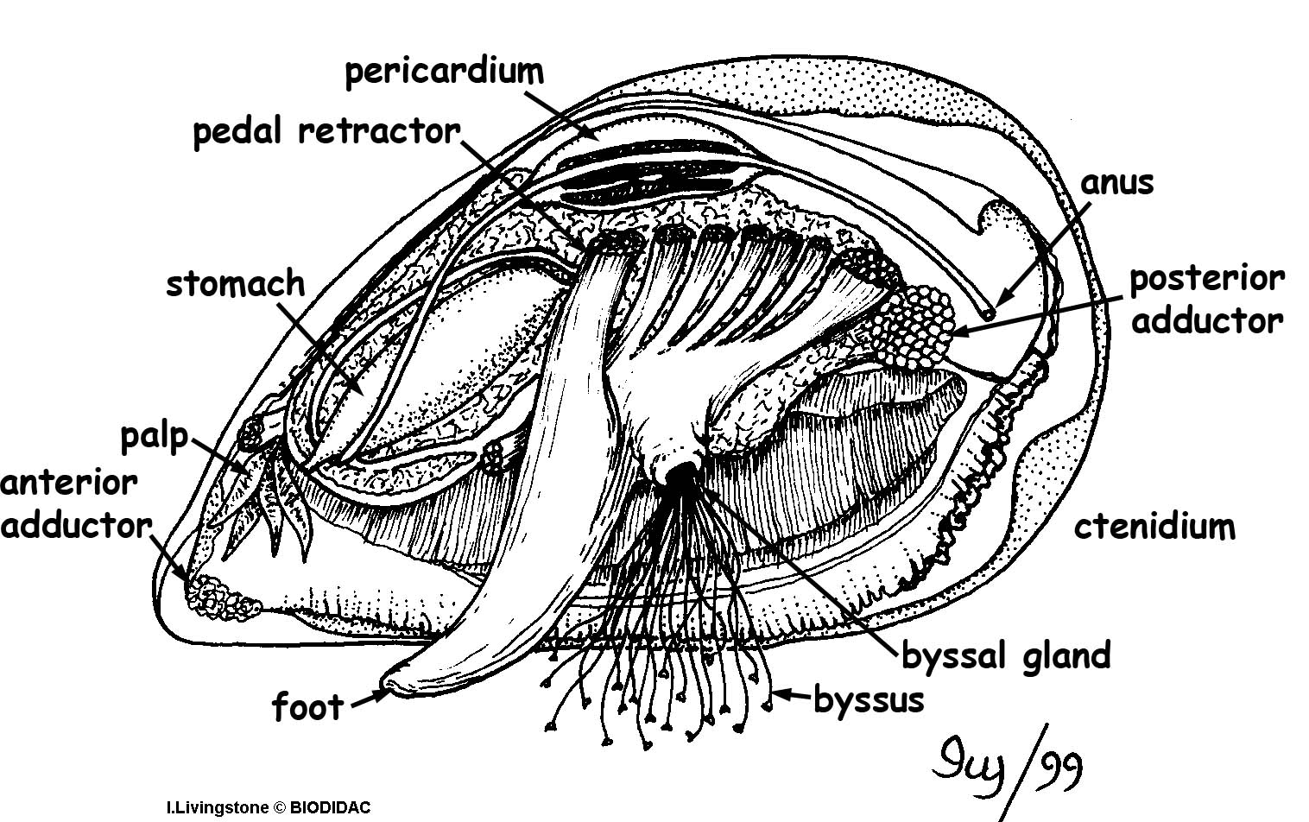black and white

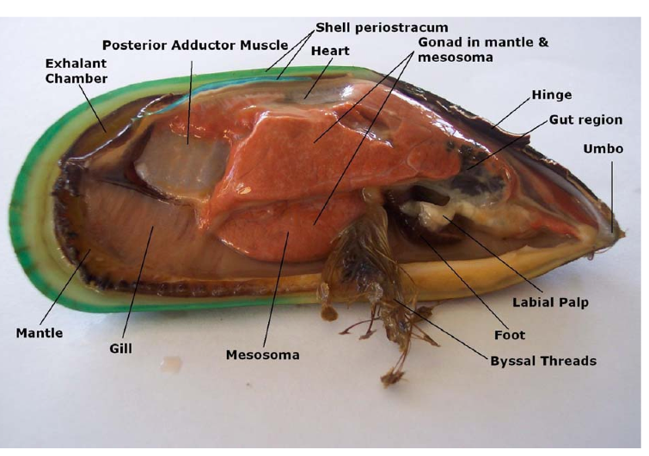

Picture of green mussel (not our species), but it indicates where you can find the heart. The intestine passes through the heart and while I could not find a muscle picture, below are pictures taken from an clam dissection that will give you a general idea of what the heart looks like. Our local species also has a red gonad when it is filled with eggs, but it is yellow or tan when not filled with eggs ready to be released.

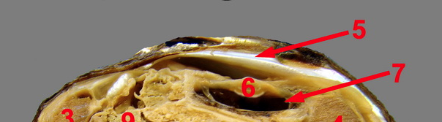Arrow 7 points to the pericardial sac of an clam and 6 to the heart. Notice the intestine passes through the heart.